Experiment No. 3:

Handling Missing Values in a Dataset

1. Aim
To study different techniques for handling missing values in datasets, including deleting columns
with small percentages of missing values and imputing missing data using dropna(), fillna(),
SimpleImputer, and KNNImputer.

2. Objectives
• To understand the concept of missing data in datasets.
• To identify missing values using Pandas functions.
• To analyze the percentage of missing values in columns.
• To delete columns with very small percentage of missing values.
• To perform imputation of missing values for numerical and categorical data.
• To learn machine learning–based imputation techniques such as SimpleImputer and KNNImputer.

3. Software Required
• Python 3.x
• Jupyter Notebook / Google Colab / Anaconda
• Pandas Library
• NumPy Library
• Scikit-learn Library

4. Introduction
In real-world datasets, missing values are very common. Missing data occurs when some values are not recorded or unavailable in the dataset.

Missing values can appear due to several reasons:
• Data entry errors
• Sensor or device failures
• Incomplete surveys or questionnaires
• Data corruption during storage or transfer

In Python, missing values are usually represented as NaN (Not a Number).
Handling missing values is an important step in data preprocessing, because most machine learning
algorithms cannot handle missing values directly.

5. Identifying Missing Values
Before handling missing data, it is important to identify and analyze missing values in the dataset.
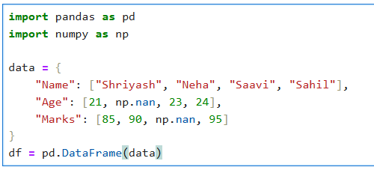
Common techniques include:
• Checking missing values using isnull()
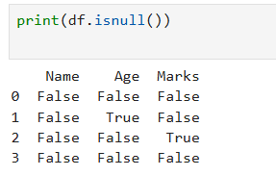
• Counting missing values using isnull().sum()
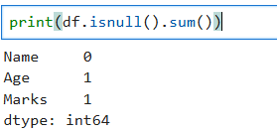
• Calculating percentage of missing values using isnull().mean() × 100
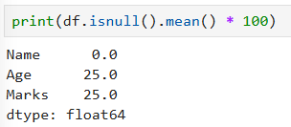
This analysis helps determine which columns require treatment.

6. Case Study: Deleting Columns with Less Than 5% Missing Values

In some cases, a column may contain very few missing values (less than 5%).

Instead of performing imputation, we may choose to remove those rows or columns if they have
minimal impact on the dataset.
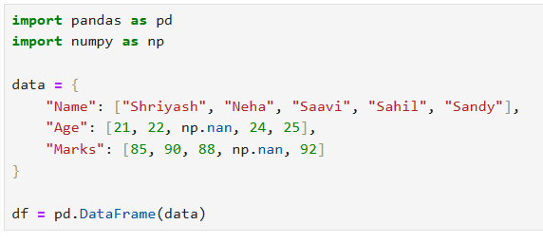
Steps involved
1. Calculate the percentage of missing values in each column.
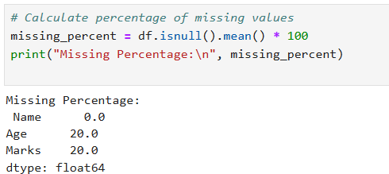
2. Identify columns where the missing percentage is less than 5%.
3. Remove the rows containing those missing values.
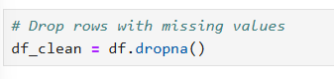
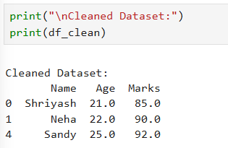

7. Imputing Missing Values Using fillna()
Imputation refers to the process of replacing missing values with estimated values.
The fillna() function in Pandas is commonly used to replace missing values.
Imputation methods depend on the type of data.
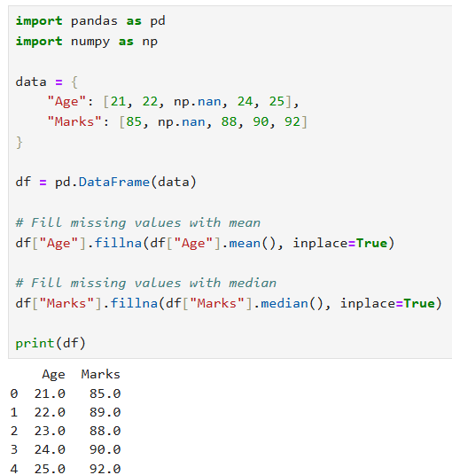
The inplace parameter in Pandas is used to modify the original DataFrame directly without creating a new copy.

7.1 Imputing Numerical Columns

For numerical attributes, common techniques include:
Mean Imputation
Missing values are replaced with the mean of the column.
This method works well when the data is normally distributed.
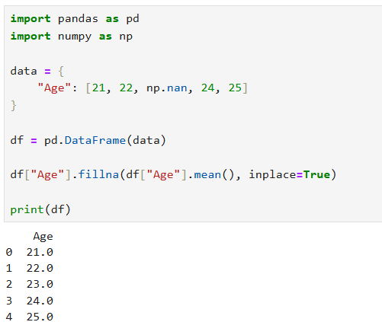

Median Imputation
Missing values are replaced with the median value of the column.
Median is preferred when the data contains outliers.
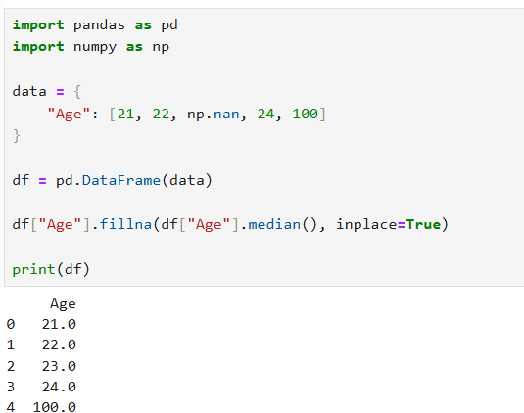


Constant Value Imputation
Missing values are replaced with a fixed constant value such as 0 or -1.
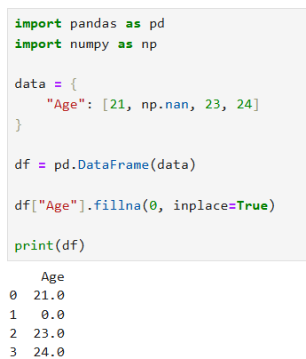

7.2 Imputing Categorical Columns

For categorical attributes, missing values are typically replaced using:

Mode Imputation
Missing values are replaced with the most frequently occurring value in the column.
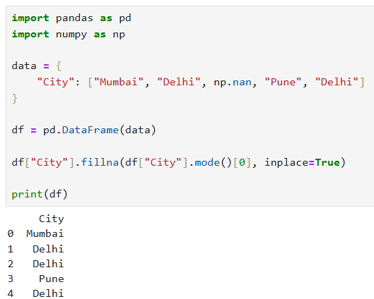

Constant Category
A special category such as "Unknown" or "Missing" can be assigned to missing values.
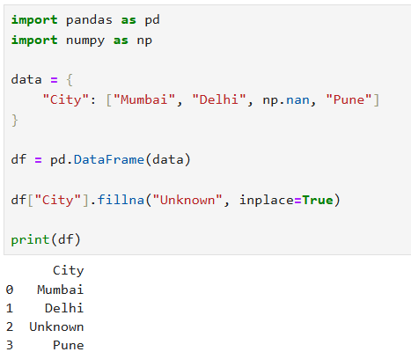

8. Imputing Missing Values Using SimpleImputer
SimpleImputer is a class available in the Scikit-learn library used to handle missing values.
It provides a systematic way to perform imputation during machine learning workflows.

Common strategies used in SimpleImputer
• Mean – replaces missing values with column mean
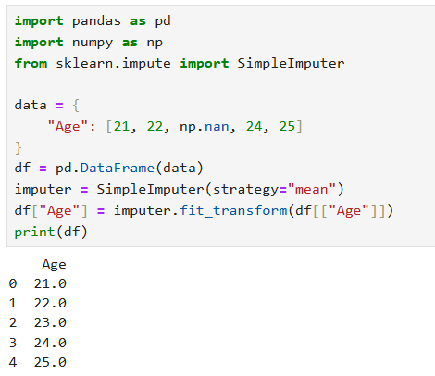

• Median – replaces missing values with column median
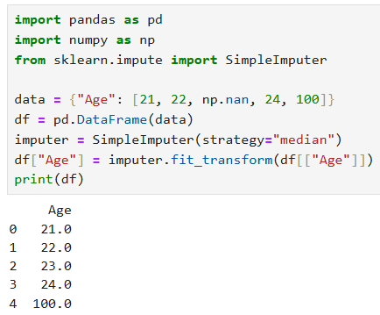
• Most frequent – replaces missing values with most common value
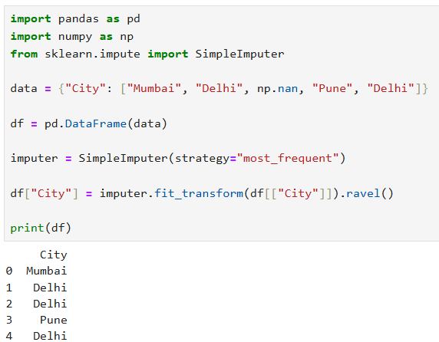

Why .ravel() is Used
fit_transform() returns a 2D array
.ravel() converts it into a 1D array, which fits a single column.

• Constant – replaces missing values with a constant value
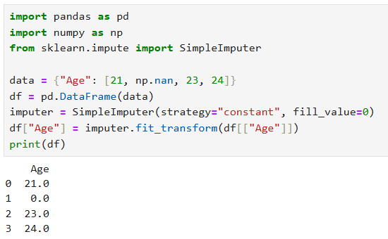

9. Imputing Missing Values Using KNNImputer
KNNImputer is an advanced technique used to fill missing values using the K-Nearest Neighbors algorithm.

In this method:
1. The algorithm finds K nearest rows with similar values.
2. It calculates the average value from the nearest neighbors.
3. The missing value is replaced with the computed average.
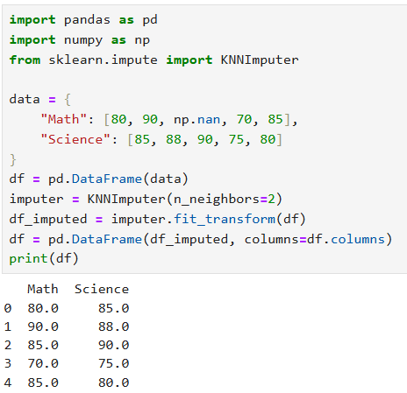

Example concept
If a student’s math score is missing, the algorithm finds students with similar features and estimates
the missing value based on their scores.

11. Result
The experiment successfully demonstrated various techniques for handling missing values, including deletion of columns with small percentages of missing data and imputation using fillna(), SimpleImputer, and KNNImputer.

12. Conclusion
Handling missing values is an essential step in data preprocessing for machine learning. Proper
treatment of missing data improves model accuracy and reliability. Techniques such as fillna(), SimpleImputer, and KNNImputer help ensure that datasets become suitable for machine learning algorithms.

Viva Questions

1. What are missing values in a dataset?
Missing values are data points that are not recorded or unavailable in a dataset, often represented as NaN or null values.

2. What does NaN represent?
NaN (Not a Number) represents missing or undefined numerical values in a dataset.

3. Why is handling missing data important in machine learning?
Handling missing data is important because many machine learning algorithms cannot work with missing values, and missing data can reduce model accuracy.

4. What is imputation?
Imputation is the process of replacing missing values with estimated values such as mean, median, mode, or other methods.

5. What is the difference between deletion and imputation?
- Deletion → Removes rows or columns containing missing values.
- Imputation → Replaces missing values with estimated values.

6. What is fillna()?
fillna() is a Pandas function used to replace missing values with a specified value or method.

7. What is mean imputation?
Mean imputation replaces missing values with the average value of the column.

8. What is mode imputation?
Mode imputation replaces missing values with the most frequently occurring value in the column.

9. What is SimpleImputer?
SimpleImputer is a Scikit-learn class used to replace missing values using strategies like mean, median, most frequent, or constant.

10. What is KNNImputer?
KNNImputer is a method that fills missing values using the average values of K nearest similar data points.

11. What is the role of K in KNNImputer?
K represents the number of nearest neighbors used to estimate the missing value.

12. When should KNN imputation be preferred?
KNN imputation should be preferred when the dataset has similar records and relationships between features, making neighbor-based estimation more accurate.

